Docker inside docker

Step 1: Start Docker container in interactive mode mounting the docker.sock as volume. We will use the official docker image.

docker run -v /var/run/docker.sock:/var/run/docker.sock -ti docker

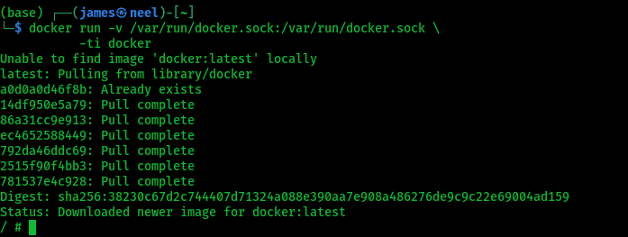

Step 2: Once you are inside the container, execute the following docker command.

docker pull ubuntu

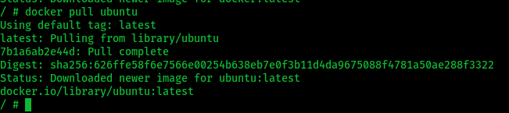

Step 3: When you list the docker images, you should see the ubuntu image along with other docker images in your host VM.

docker images

→ in docker images able to see all containers along with host images.



Step 4: Now create a Dockerfile inside test directory.

mkdir test && cd test

vi Dockerfile

Copy the following Dockerfile contents to test the image build from within the container.

FROM ubuntu:18.04

RUN apt-get update && \

apt-get -qy full-upgrade && \

apt-get install -qy curl && \

apt-get install -qy curl && \

curl -sSL https://get.docker.com/ | sh

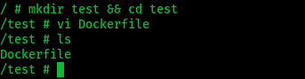

Build the Dockerfile

docker build -t test-image .

